# *Database Management I (420-D10-HR)*

# *Happy Valley Kennels Project*

# *Assignment 4 - Physical Data Model and Database Schema*

Date assigned: Monday, October 24, 2016

Date due: **Friday, October 28, 2016**

**Learning Objectives**

After completing this assignment, the student will be able to

* Convert a logical data model to an implementation model
* Generate Oracle database table creation statements from an implementation data model in Oracle Data Modeler
* Create Oracle tables, primary keys and foreign keys

**To be uploaded to Moodle:**

1. The zipped ***username_*D10_A04_Physical_Data_Model** folder containing the logical and relational data model and the ***username*_D10_A04.sql** file containing the DDL files generated by Oracle Data Modeler.

**To start:**

### Copy the ***teamNumber_*D10_A03_Fully_Attributed_Data_Model** folder from the team folder to your **420-D10\Assignments** folder and rename it to ***username_*D10_A04_Physical_Data_Model**.

**To do:**

This assignment is an **individual** assignment.

| **Task** | **Marks** |
| --- | --- |
| 1. Make corrections from Assignment 3. 5 | 5 |
| Add an attribute for the pet picture to your **Pet** entity and an attribute for a video clip to the **Daily Log** entity. | 5 |
| Add a surrogate primary key called **pet_res_number** to the **pet_reservation** entity. Change the relationships between **pet** and **pet_reservation** and between **reservation** and **pet_reservation** to non-identifying. | 5 |
| If you don't already have one, add **run-status** to the **Run** and **Cat-Suite** entities to keep track of the run (or suite) availability. **run-status** should be a single character and has the following possible values:  |  |  |  | | --- | --- | --- | | **Status** | **Meaning** | **Explanation** | | 1 | Available | The run has been cleaned and is available for a dog | | 2 | Needs cleaning | The run needs cleaning | | 3 | Broken | The run needs repair | | 5 |
| Create the implementation data model. (See instructions on the next page.) Apply the Naming Standards and add the new HVK_ prefix to the object names. | 5 |
| Rename the foreign key column for the sharing with relationship to **pr_sharing_with** in the **pet_reservation** entity for the pet who is sharing a run or cat suite with another reserved pet. | 3 |
| Specify the referential integrity constraint for all your relationships using the constraint definitions that you did in assignment 3. (See instructions on the following pages.) | 5 |
| Create the DDL files for your model. (See instructions on the following pages.) Name the DDL file ***username*_D10_A04**Correct any errors. Ensure that the constraints for your primary keys, foreign keys and any data validation that you specified in your data model documentation are included. | 5 |
| Generate the tables in Oracle | 25 |
| Organization | 5 |
| **Total** | **68** |

# Creating an Implementation model from a Logical Model in Oracle Data Modeler

### Open your logical data model.

#### Right click on the design name in the **Browser** panel. Select **Properties**. Expand **Settings** and select **Naming Standard**. Change the default separator for the logical model to “-“:

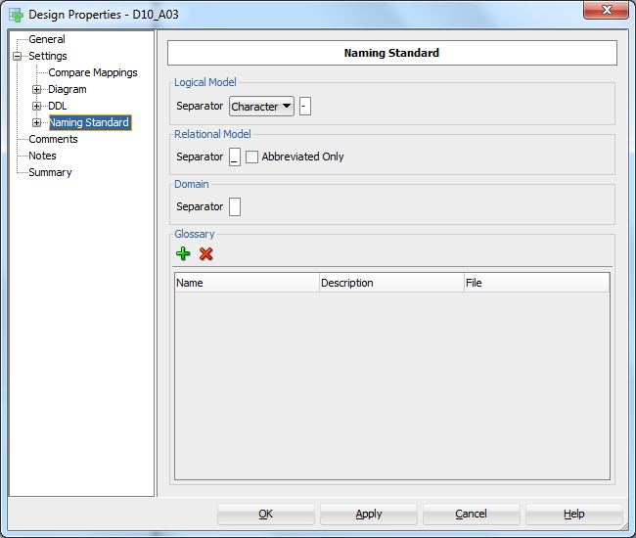

### Modify the Templates as shown here:

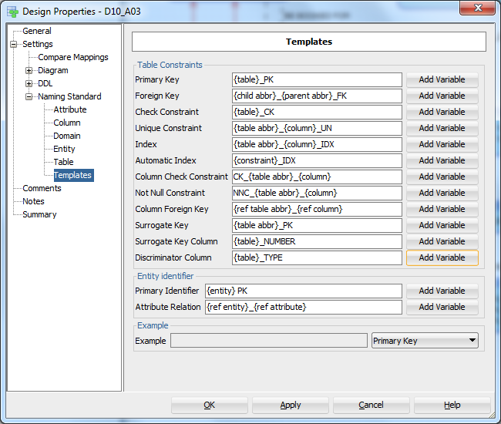

### Make the following changes to your logical model:

#### Make sure that all address and phone fields are optional.

#### Add short names for all your entities. Keep your short name to 3 or fewer characters. For concatenated entity names, use the first letter of each part. (e.g. The short name for pet reservation would be pr.)

#### Select the implementation type for your super-subtypes.

##### Open your entity super types and select **Subtypes.**

##### Select Arc Implementation from the References drop-box.

##### In the subtree generation field:

##### select "Table for each entity" for the Pet entity,

##### select "Table per child" for the Accommodation entity

### Select **Engineer to Relational Model** by clicking the **>>** icon.

### Select the **General Options** tab at the bottom and check the “Apply Name Translation” check box. Uncheck the “Use Preferred Abbreviations” check box:

### Click the **Engineer** button.

### Right-click on the relational diagram name in the **Browser**. (The default name is **Relational_1**.) Select **Change Object Names Prefix**. Check the **Add new prefix** check box. Type **HVK_** in the **New Prefix** field. Click **Apply**.

### Right-click on the relational diagram name in the Navigation panel again and select **Apply Naming Standards to Keys and Constraints**. Click **OK**.

### Open each table that contains a foreign key. Select **Foreign Keys** from the left-hand margin. Double-click on the foreign key name in the **Foreign Keys** window and select the delete referential integrity that your team decided on from the **Delete Rule** drop-down box.

### Resize your tables and move them around so that everything is visible. Avoid crossing lines if possible.

# Generating DDL statements from an Implementation model in Oracle Data Modeler

### Click the **Generate DDL** icon from the toolbar. Select **Oracle 11G** from the list of databases. (If you have already created the tables in Oracle once, click the **'Drop' Selection** tab and check all the checkboxes so that the tables you previously added will automatically be dropped before recreating them.)

### Click **Generate**. Correct any errors identified in the generation.

Note:

Most likely errors are fitting your names into the 30 character limits of Oracle. You will have to go back and reduce the size of your table/column names and re-generate the DDL.